PT_PATIENT_DATA_LOAD

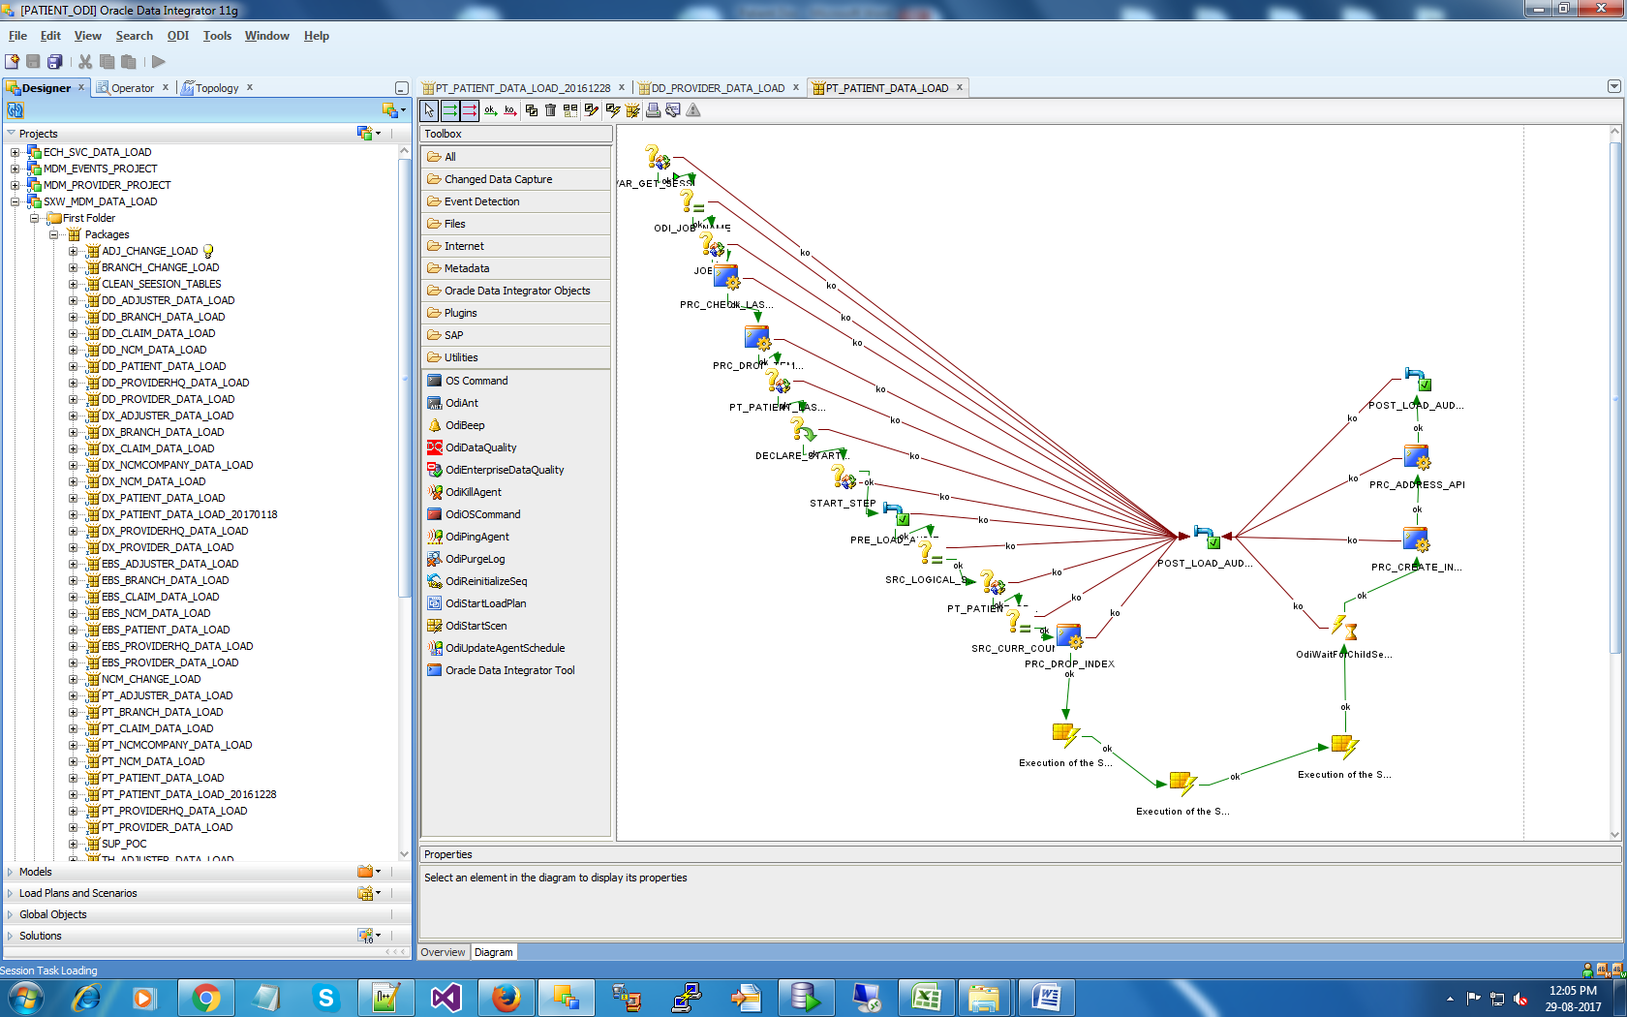

Step1:- VAR_GET_SESSION_ID

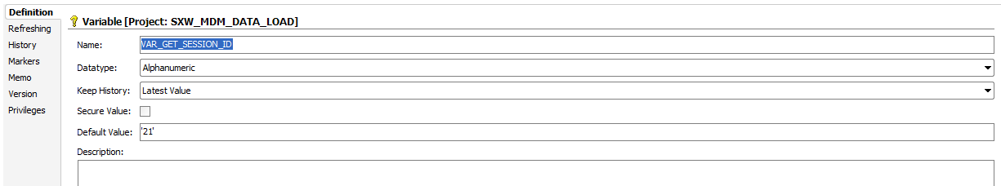

Refresh tab

select PKG_ODI.SF_GET_SESSION_ID('<%=odiRef.getSession("SESS_NAME")%>') FROM DUAL

Step2:- ODI_JOB_NAME

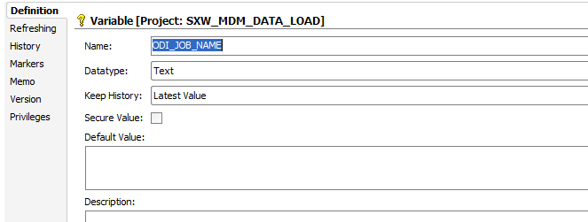

In Refreshing tab:- SELECT NULL FROM DUAL

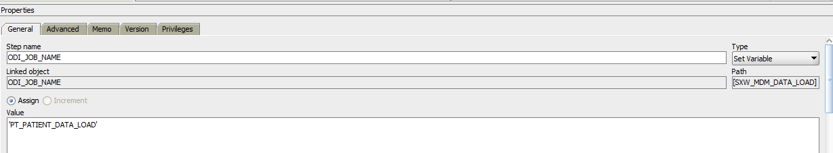

Step3:- JOB_ID

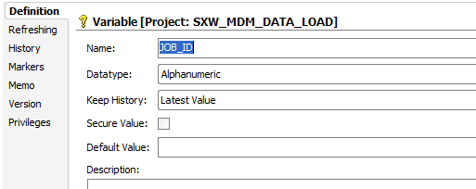

In Refreshing tab:- SELECT JOB_RID FROM <?=odiRef.getObjectName("L", "C_ODI_JOB_METADATA", "OCCM_MDM_LS", "", "D") ?> WHERE JOB_NAME = #ODI_JOB_NAME

Step4:- PRC_CHECK_LAST_LOAD(Procedure)

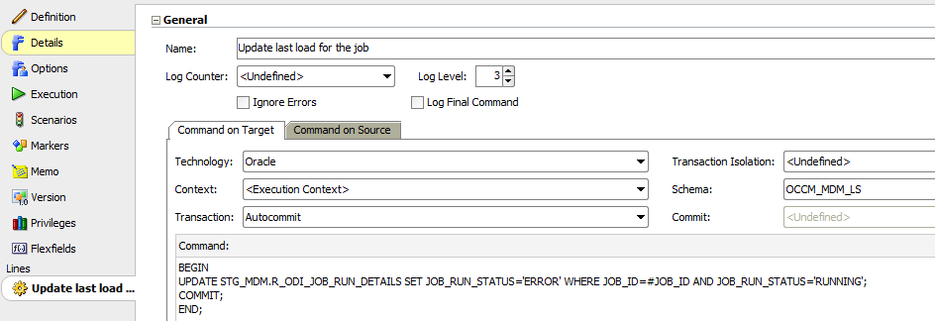

Step5:- PRC_DROP_TEMP_TABLE(Procedure)

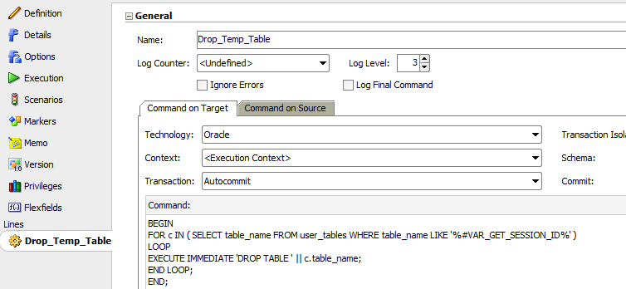

Step6:- PT_PATIENT_LAST_RUN_TIME(Refreshable variable)

In Refresh Tab:-

SELECT PKG_ODI.SF_GET_ODI_JOB_LAST_RUN_TS('PT_PATIENT_DATA_LOAD') FROM DUAL

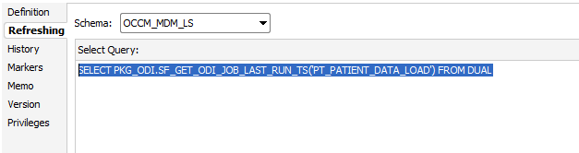

Step7:- StartTime

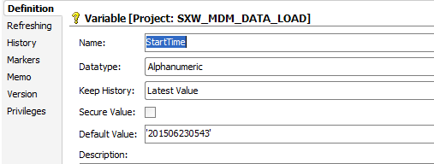

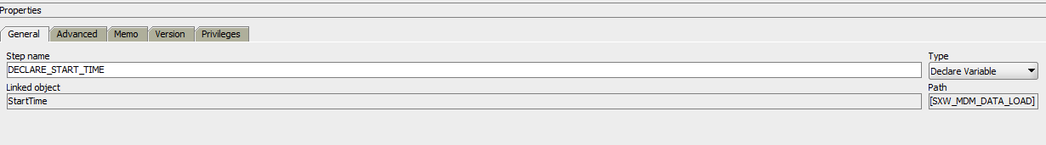

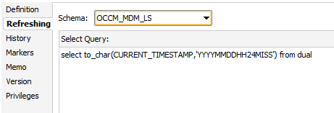

Step8:- StartTime

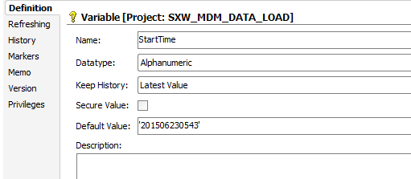

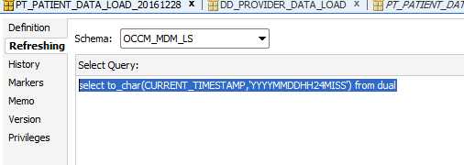

Step9:-Interface(PRE_LOAD_AUDIT)

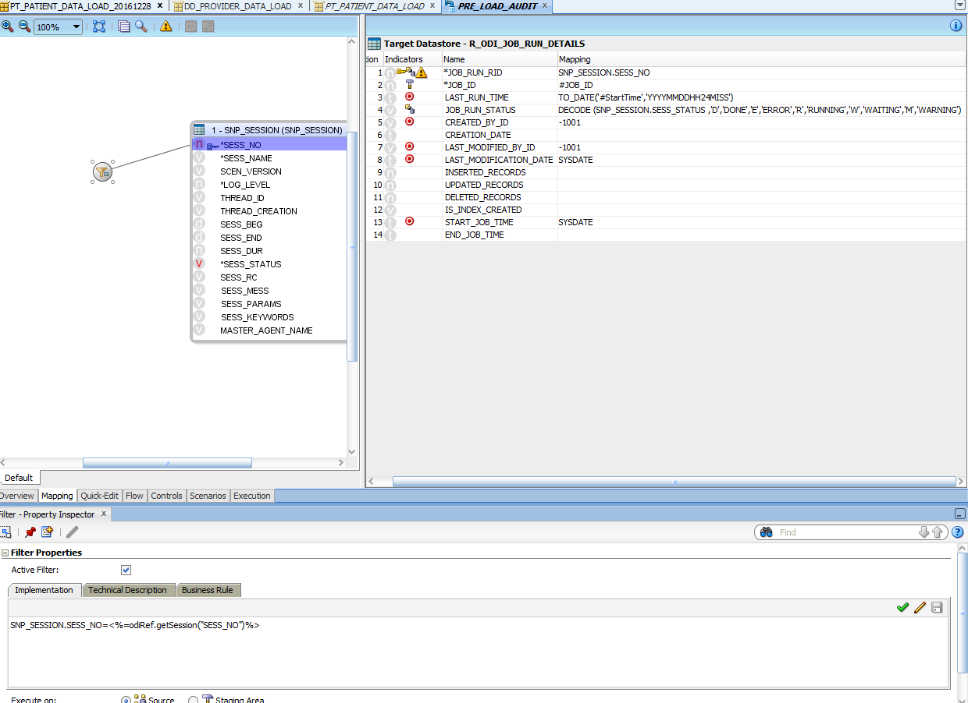

Filter condition:- SNP_SESSION.SESS_NO=<%=odiRef.getSession("SESS_NO")%>

Step10:- SRC_LOGICAL_SCHEMA

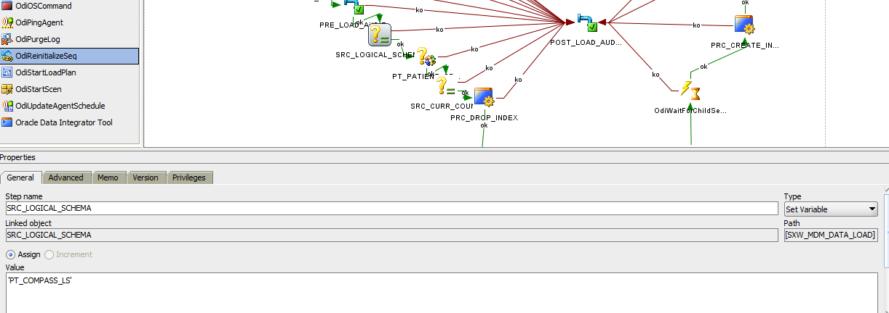

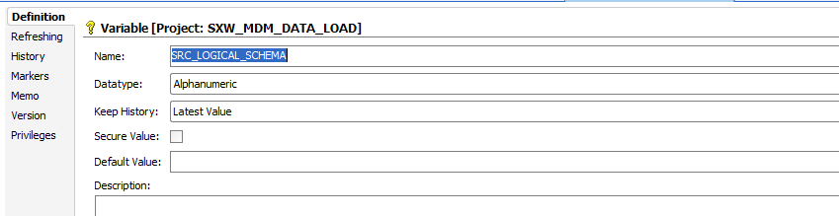

Step11:- PT_PATIENT_SRC_COUNT(Refresh Variable)

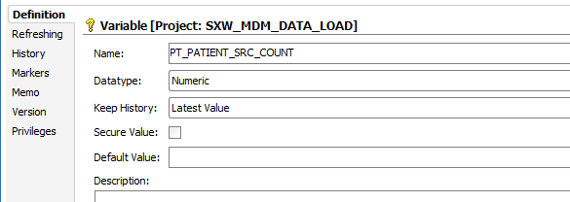

In Refresh tab:-

select count(*) FROM [<%=odiRef.getCatalogName("PT_COMPASS_LS", "D")%>].[<%=odiRef.getSchemaName("PT_COMPASS_LS", "D")%>].V_PATIENT_MDM

WHERE

SOURCE_LAST_MODIFICATION_TS > CAST('#PT_PATIENT_LAST_RUN_TIME' AS datetime)

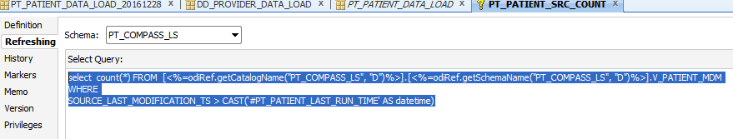

Step12:- SRC_CURR_COUNT(set variable)

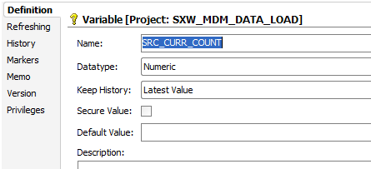

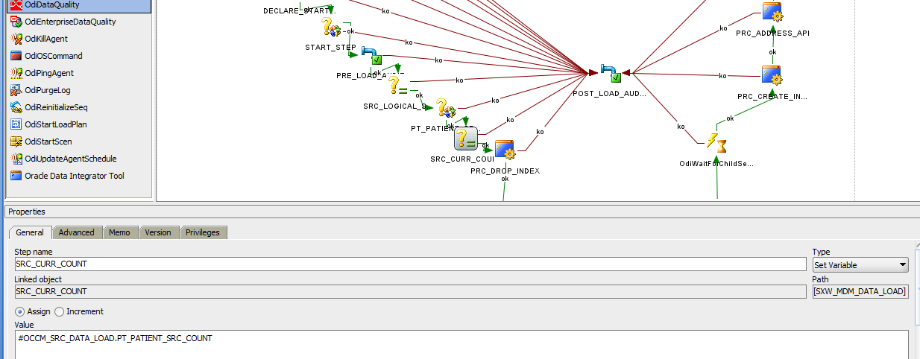

Nothing in Refresh Tab

Step13:- PRC_DROP_INDEX

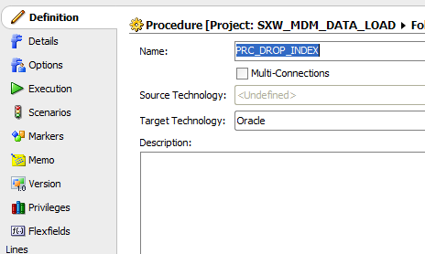

Command on Source:-

SELECT SUM(row_count) TOTAL_COUNT,<%=odiRef.getSession("SESS_NO"

)%> SESS_NO FROM (

select NVL(sum (INSERTED_RECORDS),0) row_count from STG_MDM.r_odi_job_run_details where job_id=#JOB_ID and IS_INDEX_CREATED='N'

union

select #OCCM_SRC_DATA_LOAD.SRC_CURR_COUNT row_count FROM DUAL)

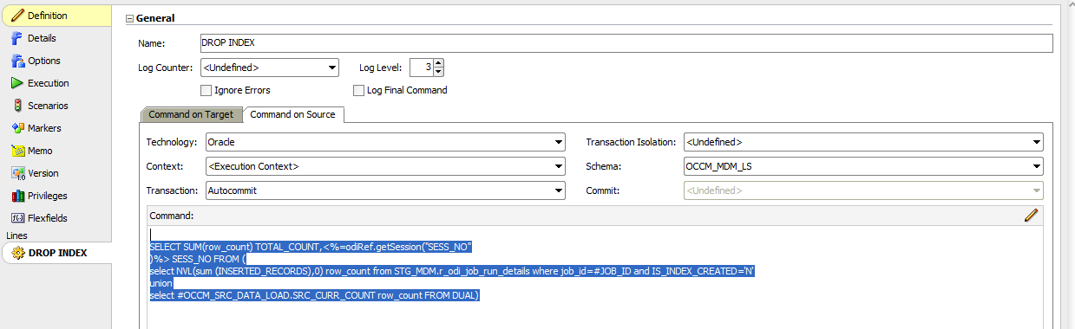

Command on Target:-

BEGIN

IF( :TOTAL_COUNT >= 1000) THEN

PKG_ODI.SP_ODI_DROP_INDEX(#ODI_JOB_NAME,:SESS_NO);

END IF;

END;

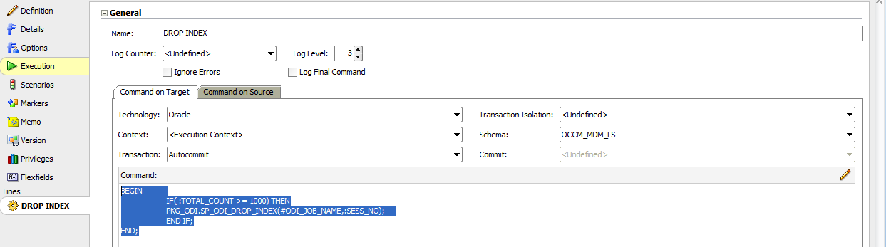

Step14:-(3 Interface)

Step15:- OdiWaitForChildSession 4

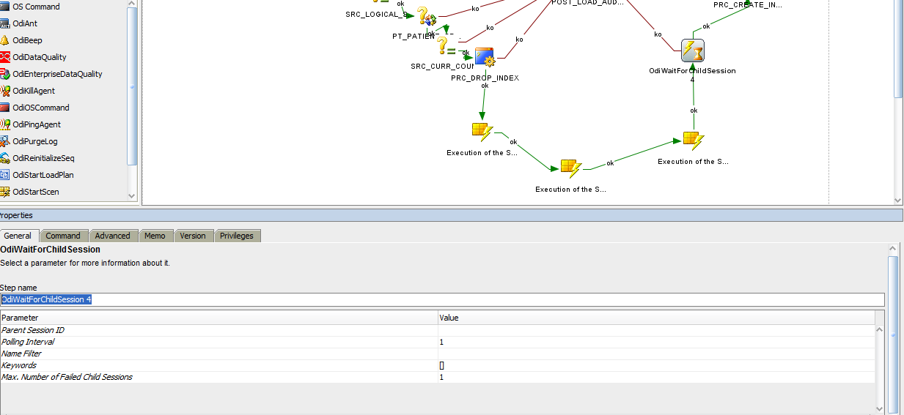

Step16:- PRC_CREATE_INDEX(Procedure)

Command on source:- select IS_INDEX_CREATED,<%=odiRef.getSession("SESS_NO")%> SESS_NO FROM STG_MDM.R_ODI_JOB_RUN_DETAILS WHERE JOB_RUN_RID=<%=odiRef.getSession("SESS_NO")%>

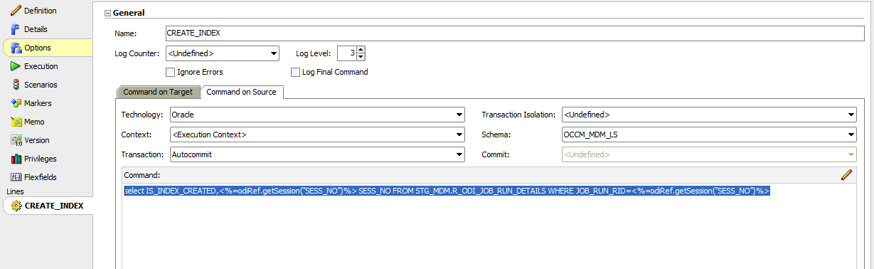

Command on Target:-

BEGIN

IF(:IS_INDEX_CREATED ='D') THEN

PKG_ODI.SP_ODI_CREATE_INDEX(#ODI_JOB_NAME,:SESS_NO,#JOB_ID);

ELSE

UPDATE STG_MDM.R_ODI_JOB_RUN_DETAILS SET IS_INDEX_CREATED='N' WHERE JOB_RUN_RID = :SESS_NO AND JOB_ID=#JOB_ID;

COMMIT;

END IF;

END;

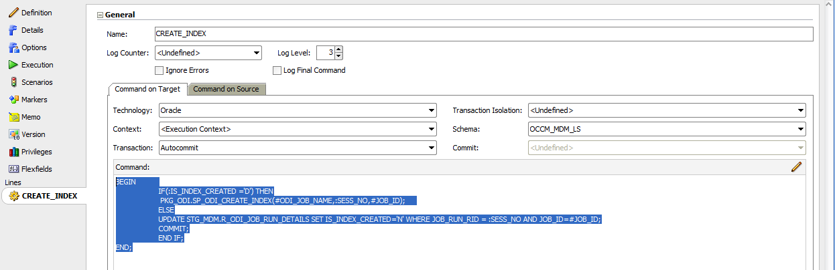

Step17:- PRC_ADDRESS_API(Procedure)

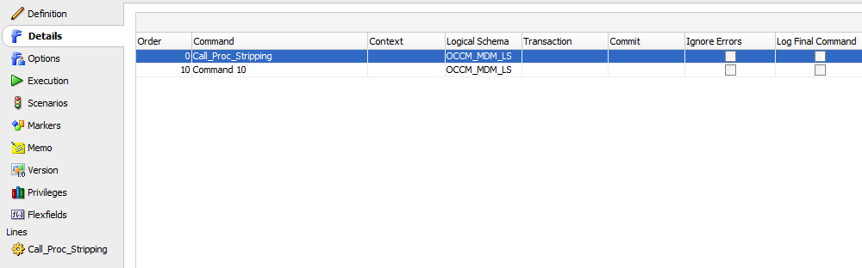

Procedure1:-( Call_Proc_Stripping)

Command on source:- select

'<%=odiRef.getPackage("PACKAGE_NAME")%>' as JOB_NAME

from dual

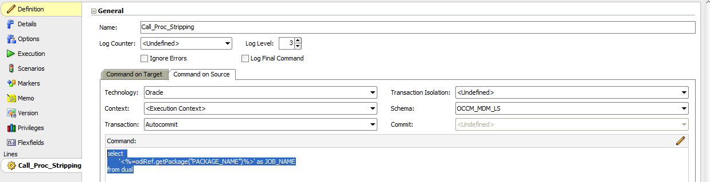

Command on Target :- BEGIN

PKG_ODI.SP_RM_STR_BRANCH_COMP_NAME(:JOB_NAME);

END;

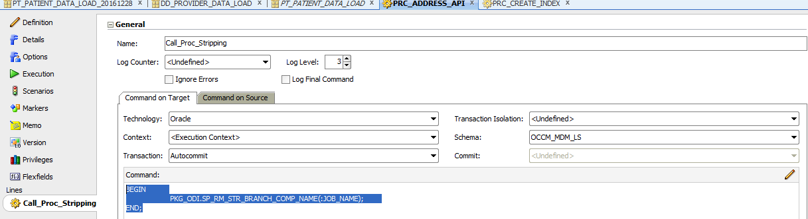

Procedure2:-

Command on source:- SELECT

'<%=odiRef.getPackage("PACKAGE_NAME")%>' as PACKAGE_NAME

from dual

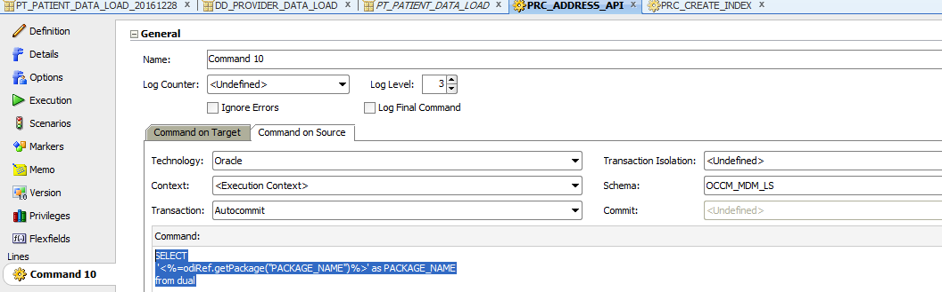

Command on Target:-

BEGIN

PKG_ODI.SP_SAVE_ADDRESS_API(:PACKAGE_NAME);

PKG_ODI.SP_MDM_DATA_POSTLOAD(:PACKAGE_NAME);

END;

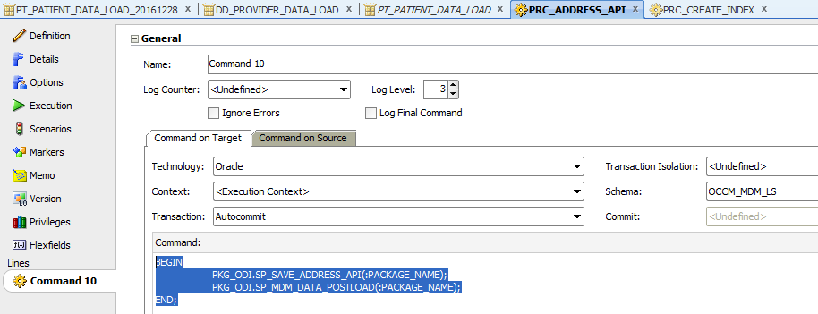

Step18:- POST_LOAD_AUDIT_SUCCESS(interface)

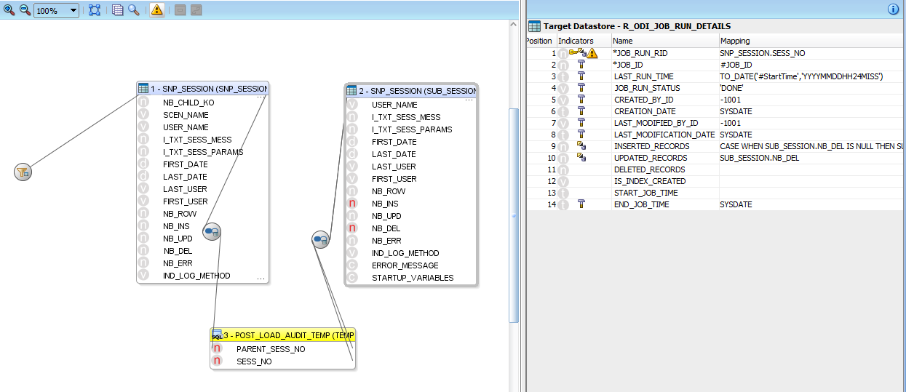

Inserted_records:-

CASE WHEN SUB_SESSION.NB_DEL IS NULL THEN SUB_SESSION.NB_INS ELSE SUB_SESSION.NB_INS-SUB_SESSION.NB_DEL END

Filter Condition:-

SNP_SESSION.SESS_NO=<%=odiRef.getSession("SESS_NO")%>

Join1:- SNP_SESSION.SESS_NO=TEMP_MIN_THREAD_CREATION.PARENT_SESS_NO

join2:- TEMP_MIN_THREAD_CREATION.SESS_NO=SUB_SESSION.SESS_NO AND TEMP_MIN_THREAD_CREATION.PARENT_SESS_NO=SUB_SESSION.PARENT_SESS_NO